Submission Title, Should Fit on One Line

If your title does not fit onto one line, then you can use the subtitle line

GivenName FamilyName, GivenName FamilyName and GivenName FamilyName

Replace the text by inserting your paper number submission

This document is the template to format your revised ‘camera ready’ Paper, Case Study, Workshop or Visual Paper copy contribution for the LxD.2021. The revised submissions are due by 8 June 2021. Submit your contribution on the conference review system at <https://www.conftool.com/learnxdesign2021/> The abstract should be no more than 170 words. Please use Styles provided in this document to format the text. You can select to view the Styles pane while you insert your text into this document using either Microsoft Word, LibreOffice or Apache OpenOffice. There you will see the available styles for paragraphs, headings, quotes, etc. If you paste text from another document, make sure you paste it as ‘Paste’ > ‘Keep text only’ or ‘Paste special’ > ‘Unformatted Text’, and format the text after it has been inserted. Edit your document carefully in order to keep the formatting tidy. The aim is to produce the conference proceedings using a consistent style. Please try to fit your paper title into one line only. Style: Abstract

Keywords: contribution template; key word; five maximum; style: Keywords

# Introduction – style: Heading 1

All full ‘final’ submissions have been selected through a double-blind review process conducted by an international review panel. You will need to make two uploads of your final submission using this template via the conference management system <https://www.conftool.com/learnxdesign2021/> plus providing a ‘Statement of Paper Revision’ in the ‘rebuttal’ field box:

1. A Word version of your submission, name the file using your submission number, e.g. 120.docx (see Figure 1.)

2. A PDF version of your submission, name the file using your submission number, e.g. 120.pdf

The Word file will be used to compile the proceedings. The PDF will be made available to conference delegates prior to the conference via the online conference programme.

Irrespective of the range and stage of your research, we expect high standards of scholarship and clarity in terms of establishing context, explicating methods of inquiry, and reporting results. If English is not your first language, please ensure that a fluent speaker proofreads your paper or use a proof reading service such as Scribendi (<http://www.scribendi.com>).

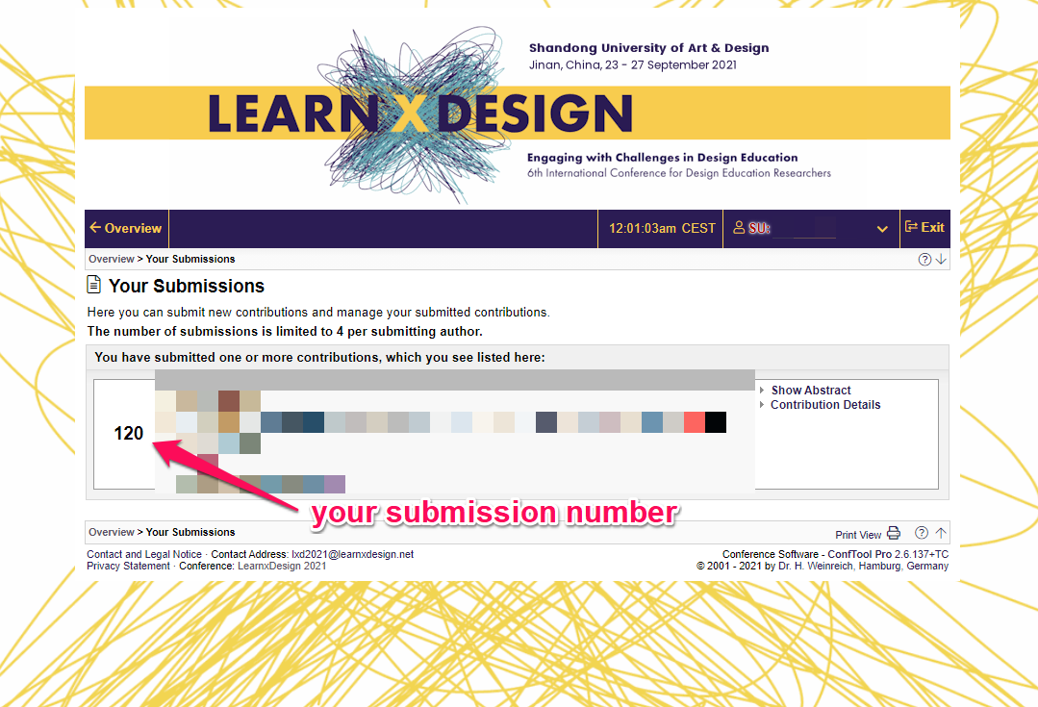

Figure 1. You can find your paper number by login on <https://www.conftool.com/learnxdesign2021/> and selecting [**Your Submissions**](https://www.conftool.com/learnxdesign2021/index.php?page=submissions)

This template document itself uses the same formatting as required for the conference so your full submission should appear visually similar. You can access formatting styles for headings, paragraphs, and other styles directly from the Styles pane, or from the Quick Style menu that is part of the Home menu in Microsoft Word (2007 and above). To emphasise text, for example, you can select the *‘Emphasis’* or**‘Intense Emphasis’**style. You can either write directly into this document or paste your finished text into it and select to ‘Paste’ > ‘Keep text only’ or ‘Paste special’ > ‘Unformatted Text’. Do not change the predefined format settings in this document (such as paper size, orientation, margins, typeface, size, indents, spacing, etc.).

# How your contribution will be published – level Heading 1

All papers will be published in the online proceedings which will have an ISBN numbers and be made accessible from the L**x**D.2021 conference management portal prior to the conference. The conference papers will be given a doi reference to ensure they are picked up in scholarly web-searches. We aim to produce conference proceedings of a professional and consistent quality, and appreciate you carefully following the instructions outlined in this guide. Please note that papers not following paper formatting conference template guidelines may be excluded from the conference proceedings.

# Completing your paper submission – level Heading 1

The heading 1 should be always followed by a text and never by another subheading. The reason is that the section following the heading should be always introduced like example which follows.

This section provides instruction on general guidelines which include: table formatting, headings, bullets, lists and referencing.

## General Guidelines – Heading 2

The sections of your paper should be separated by appropriate headings. Though do not go deeper than three sub-heading (i.e. heading 3 is fine but heading 4 is not). All full stops should have only one space following them. With the exception of the abstract all paragraph text is not justified. Please do not insert an extra line after a text paragraph.

### Table Formatting

Tables should be formatted as Table 1: left aligned text in the first column and centred text thereafter, if possible. Only horizontal table grid lines should be used. Add one empty paragraph line following a table.

Alternatively, complex tables can be inserted as images to ensure their consistency while the proceedings are assembled.

For clarity please consider how best to format the Tables elements, such as its headers, rows or columns (compare this table’s formatting with Table 1, below). For complex lists or Tables, we recommend constructing these outside of this document and importing them as images to keep the desired formatting structure. Although the tables constructed this way are inserted as images, you will still need to place the caption above the Table.

Table 1. Table layout, captions for Tables are placed above and for the Table Headers use ‘Table Header’ and for the text in the cells use the ‘No Spacing’ style.

|  |  |  |
| --- | --- | --- |
| Table heading | Table heading | Table heading |
| First Row | 1 | 1 |
| Second Row | 2 | 2 |
| Third Row | 3 | 3 |

### Numbered or Bullet Lists

For lists of material you can either use a bulleted list – style: List Paragraph:

* Design
* Innovation
* Management

Or a numbered list:

1. Research
2. Perspectives
3. Transformations

Please try to position the list so that it is not split across two pages.

## Use of Visual Material – style: Heading 2

Please think carefully about the presentation of any visual material. As the proceedings will be published in digital form you have the opportunity to include good quality colour images or other media files that help to present your research and its context. **It is your responsibility to ensure that you have rights and permission to use all the images in your paper.**

Where possible please make images:

* large enough to see clearly
* of good resolution (at least 200dpi)
* optimised
* cropped appropriately

If you are using diagrams, info graphics, or other schematics please ensure that:

* you present information clearly
* you use the Calibri font
* all text is legible (i.e. appropriate size and not cropped)

After you insert an image into your document, select it and use the style named **Image**. Images need a caption with figures numbered sequentially – Figure 1., Figure 2., etc. Ensure that your caption adequately describes what you want your reader to see in the picture, highlighting any areas that they should focus on. Relationships that you might want readers to see need to be outlined in the body text. If the image is not yours, you will need to acknowledge/cite its source following the caption as indicated below.

Figure 1. Captions are placed under the images/pictures. source: ©Katja Thorning 2021

After you have inserted an image into the document, select the image and apply style ‘Image’, see point 1 in Figure 2. Then, check for the image that the ‘Layout Options’ is selected as ‘In Line with text’, as shown with point 2 in the same figure below. Note that there are no extra paragraph marks before or after the image.

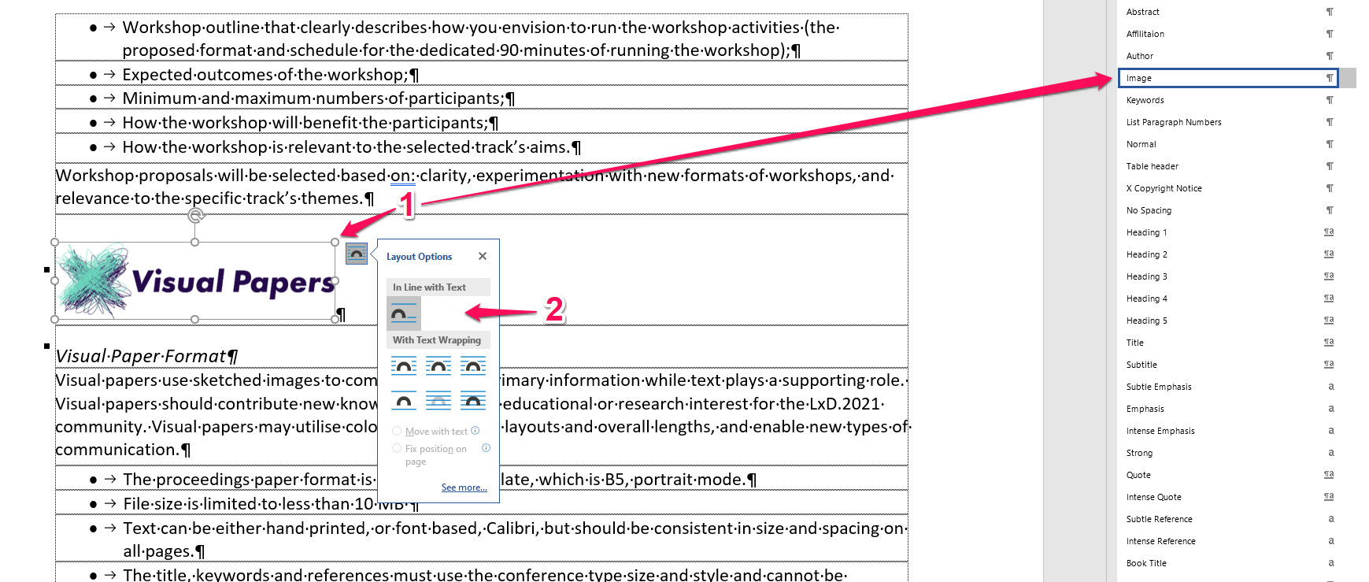

Figure 2. Applying formatting to the images

# Referencing style to be used – level Heading 1

Referencing should follow the APA 7th Manual of Style author-date system at <http://www.apastyle.org/> Within the main text, references should be placed in parentheses (Jones, 2012). For a work by two authors, use the word "and" between the authors' names within the text and use the ampersand (“&”) in the parentheses. With more than two authors (Merry, Mungo & Midegely, 2014) please list all the authors for the first time, and subsequently only the first author followed by ‘et al.’ (Merry et al., 2014). For six or more authors use the first author's name followed by et al. More examples can be accessed via this link <https://owl.purdue.edu/owl/research_and_citation/apa_style/apa_style_introduction.html>

Short quotations within the text should be marked with double quotation marks and the in-text reference will need to include the page number: Lawson (2004) also has a broad understanding of design when he mentions: “Professional designers such as architects, fashion designers and engineers” (p. 5). Longer quotations of more than one line should be formatted as below, but do not use any quotation marks:

More of the goods and services produced for consumer across a range of sectors can be conceived of as ‘cultural’ goods, in that way they are deliberately inscribed with to generate desire for then amongst the end uses sold to consumers in terms of particular clusters of meaning indicates the increased importance of ‘culture’ to production circulation of a multitude of goods and services.   
(du Gay, Hall, Janes, Mackay, & Negus, 1997, p. 24)

## Referencing – style: Heading 2

If you use reference management software such as EndNote, Word Citation & Bibliography, RefWorks, or Zotero make sure that you submit your paper with the fields unlinked to your bibliographical database. How to do this for EndNote please see this link: <http://guides.library.manoa.hawaii.edu/endnote/removecodes> or <https://sites.google.com/site/endnoteenglish/endnote/cite-while-you-write_cwyw/yi-chu-can-shu_remove-field-cod>.

If you require the paper template saved in a previous version of the Microsoft Word Document file format, please contact us via this email address: [lxd2021@learnxdesign.net](mailto:lxd2021@learnxdesign.net)

The contributions must be previously unpublished.

## Fair Use of This Format Template

Although this contribution formatting template is publicly available and you are welcome to use it beyond this event, please let us know by email [lxd2021@learnxdesign.net](mailto:lxd2021@learnxdesign.net) about your event.

# Key conference dates

The two tables below list the key conference dates.

Table 4. The key L**x**D.2021 dates as of 09 May 2021

|  |  |
| --- | --- |
| Deadline for Full Papers with Corrections | **Tuesday 8 June 2021** |
| Review Outcomes Notification for Papers Requiring Major Revision | **Tuesday 13 July 2021** |
| Registration of Author(s) Early Bird | **Tuesday 3 August 2021** |

Table 5. The key L**x**D.2021 dates as of 09 May 2021

| **Learn×Design.2021 will take place on** | **the following dates** |
| --- | --- |
| **Presentation of the Accepted** :: Research Paper :: Visual Paper :: Case-study :: Workshop | **24–26 September 2021** |

# References

du Gay, P., Hall, S., Janes, L., Mackay, H., & Negus, K. (1997). *Doing Cultural Studies: The Story of the Sony Walkman*. London: Sage.

Ghassan, A., & Bohemia, E. (2013). From Tutor-led to Student-led design education: the Global Studio. In J. Beate Reitan, P. Lloyd, E. Bohemia, L. Merete Nielsen, I. Digranes, & E. Lutnæs (Eds.), *Proceedings of the 2nd International Conference for Design Education Researchers: Design Learning for Tomorrow – Design Education from Kindergarten to PhD* (Vol. 1, pp. 524–536). Oslo, Norway: ABmedia.

Lawson, B. (2004). *What Designers Know*. Oxford: Architectural Press.

Kamler, B., & Thomson, P. (2013). *Writing for Peer Reviewed Journals: Strategies for Getting Published*. Abingdon, Oxon: Routledge.

Norman, D. (2010, 20 Jan 2011). Why Design Education Must Change. *Core77*. Retrieved from <http://www.core77.com/blog/columns/why_design_education_must_change_17993.asp> [accessed on 20 Jan 2015]

Rancière, J. (1991). *The Ignorant Schoolmaster: Five Lessons in Intellectual Emancipation* (K. Ross, Trans.). Stanford, California, USA: Stanford University Press.

Tovey, M., Porter, S., & Newman, R. (2003). Sketching, concept development and automotive design. *Design Studies*, 24, 135–153. doi:10.1016/S0142-694X(02)00035-2

Ulrich, K. T., & Eppinger, S. D. (1995). *Product Design and Development*. Singapore: McGraw-Hill.

Ulrich, K. T., & Eppinger, S. D. (2004). *Product Design and Development* (3rd ed.). New York, NY: McGraw-Hill/Irwin.

**AuthorGivenName FamilyNameAuthor**

Replace with Author’s Affiliation, Country

*replace with author’s email*

Please replace this text with author’s biography. You can use up to 70 words. For the subsequent authors please make as many new entries below for each specific author. This paragraph has 34 words.

**AuthorGivenName FamilyNameAuthor**

Replace with Author’s Affiliation, Country

*replace with author’s email*

Please replace this text with author’s biography. You can use up to 70 words. For the subsequent authors please make as many new entries below for each specific author. This paragraph has 34 words.

**AuthorGivenName FamilyNameAuthor**

Replace with Author’s Affiliation, Country

*replace with author’s email*

Please replace this text with author’s biography. You can use up to 70 words. For the subsequent authors please make as many new entries below for each specific author. This paragraph has 34 words.